Hospital Workflow Simulation Continued Implementation

by

Alexander Crichton, n6878296  
and  
Daniel Kim, n6889123

15/06/2014

Unit Coordinator: Dr Ernest Foo

Project Supervisor: Dr Ross Brown

**Change Log**

**V1.1**

The document has been colour coded  
- No background colour for unchanged content  
- Yellow background colour for updated/revised content   
- Blue background colour for new/added content

- Added a section about bot work agents to the Technical Overview   
- Added sections about avatars, animations, the navigation mesh, and controlling bots to the Implementation section  
- Added some non-implementation specific issues to the Known Issues section  
- Updated the Technical Overview section with a lot more detail  
- Updated the Scope section for this iteration  
- Updated the Execution section with the new implementation demonstration  
- Updated the setup instructions in Appendix A  
- Updated the simulation to YAWL communication sequence diagram in Appendix B  
- Moved the Simulation Model from the Implementation section into to Technical Overview  
- Removed the OpenSim to Unity detailed porting process  
- Removed some resolved issues from the Known Issues section

**V1.0**- First iteration

# Table of Contents

Table of Contents ii

1 Introduction 1

2 Project Background 2

2.1 Reimplementation Motivations 2

2.2 Chosen Development Solution 2

2.3 Project Setup 2

3 Technical Overview 3

3.1 Project Architecture 3

3.1.1 Graphic Client 4

3.1.2 Simulation Model 4

3.1.3 Database 4

3.1.4 Web Interface 5

3.1.5 YAWL Relay 5

3.1.6 Web Server 5

3.1.7 YAWL 5

3.2 Simulation Model 5

3.2.1 Work Agents, Work Enactors, and Avatars 5

3.2.2 Simulation Component 6

3.2.3 Data Component 7

3.2.4 Implementation Component 7

3.2.5 Logical Structure 7

3.3 Simulation Process 8

3.3.1 Simulation Update 8

3.3.2 Work Item Process 10

3.3.3 Asset Movement 11

3.4 Bot Work Agents 12

3.4.1 Work Cases 12

3.4.2 Work Agent Process 12

4 Implementation 13

4.1 Scope 13

4.2 Avatars 14

4.3 Animation and Mecanim 14

4.4 Environment 16

4.5 Navigation Mesh 17

4.6 NavMesh Component 18

4.7 Graphic User Interface 19

4.8 Simulation Control 20

4.9 Asset Interaction 21

4.10 Changing control as a Bot to Human 21

5 Execution 24

5.1 Relevant Interface Overview 24

5.1.1 YAWL Relay Console Interface 24

5.1.2 YAWL Web Interface 24

5.1.3 World State Table View 26

5.1.4 Asset Service Routine Table View 26

5.1.5 Case Diagram 26

5.2 Starting the Simulation 28

5.3 Bots Working Autonomously 30

5.4 Branching Workflows 33

5.5 Human Participation 36

5.6 Completing the Simulation 40

6 KNOWN ISSUES 42

6.1 Issues Specific to this Implementation 42

6.1.1 Unity Type Threading Issues 42

6.1.2 Unity DLL Conflicts [Legacy] 43

6.2 Issues Not Specific to this Implementation 45

6.2.1 YAWL Communication Challenges 45

6.2.2 Simulation Concurrency 46

6.2.3 Simulation Reset Unreliable 46

6.2.4 Database Missing Some Asset Methods 46

7 Future Development 49

7.1 Web Interface Integration 49

7.2 Multiple Users 49

References 50

Appendix A Project Setup Instructions 51

Web Server 51

YAWL 51

YAWL Relay 52

Unity Application 52

Appendix B YAWL Relay Communication Handling 53

# Introduction

The project referred to in this report is a continuation of previous efforts. The long-term goal of the project is to produce an interactive and collaborative virtual environment capable of simulating real-life hospital scenarios for training and education purposes. The simulation utilises a Business Process Management Workflow tool called YAWL to handle scenarios and to distribute tasks between participants. The client for user interaction was originally implemented in OpenSim but has since been migrated to Unity with which it shall continue to be developed for the foreseeable future.

This report details the project’s continued development. This report does not detail previous project development, except in some select sections such as Section 2, which outlines the project’s existing architecture, motivations for the client migration, and justification for continuing development in Unity. Section 3 describes the project architecture, including the simulation model and its processes in greater detail. Section 4 describes the current state of the significant features that have been developed during this stage of the project implementation. Section 5 demonstrates the significant functionalities of the current implementation. Section 6 mentions any significant known issues, both those pertaining specifically to this implementation in Unity as well as those which apply to any implementation. Section 7 discusses some possible future features.

# Project Background

## Reimplementation Motivations

The previous client implemented in OpenSim was functional but littered with problems. It was comprised of an OpenSim server and a graphic client for user interaction. The OpenSim server is a large, pre-release, open source application with many features, a large portion of which are not relevant to this project. The graphic client was one of a number of third-party open source applications for connecting to virtual worlds.

The previous client was unreliable, and it was in the long-term interest of the project to investigate an alternative development solution with stability, support, and efficient, dedicated tools.

## Chosen Development Solution

Many possible solutions for developing graphic clients exist, but they are not all equally suited to this project. The optimal development solution needs to suit both the technical needs and the relatively small scale of the project. The previous implementation in OpenSim suggests a solution with a toolset more closely aligned with the needs of the project.

The range of video game development tools offers more relevant and effective solutions. There are many to consider: Unreal Development Kit, CryENGINE, Game Maker Studio, and Source Engine are some of the more notable ones. The most appropriate has been deemed to be Unity for its relative ease of use and comparatively high productivity potential for small development environments.

## Project Setup

Instructions for setting up the project can be found in Appendix A.

# Technical Overview

This section describes the general project architecture from several levels, detailing the important components and their interactions. This document version includes updates to the existing component descriptions and diagrams for more accurate representations of interactions, further description of the most significant component, the Simulation Model, and information about the recently implemented bot work agents.

## Project Architecture

Figure 1 illustrates the general project architecture. Generally it is conceptually easier to imagine a smaller hierarchy consisting of the two end points (the Database and YAWL) and the Client Simulation which is the controller (see Figure 2).

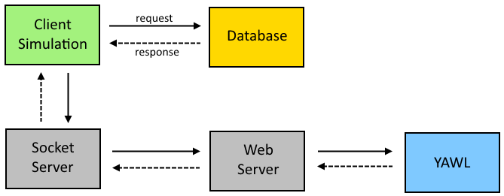

Figure 1. Top level project architecture.

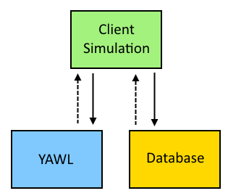

Figure 2. Project logical hierarchy controlled by the Client Simulation.

The Client Simulation is technically one application, but should be logically regarded as having three parts: a Graphic Client, a Web Interface, and a Simulation Model (see Figure 3).

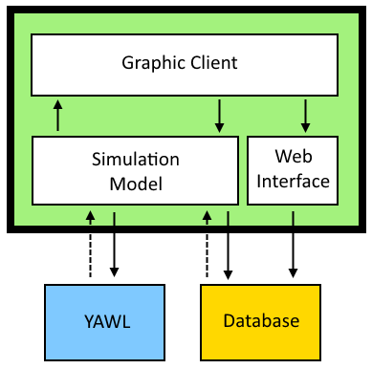

Figure 3. Logical architecture for the Client Simulation.

### Graphic Client

The Graphic Client is the virtual environment that the user perceives and interacts with. This requires a platform-specific implementation; previously it was implemented using the OpenSim framework, though it has since been implemented using Unity.

### Simulation Model

The Simulation Model plays the most diverse role. It handles all of the workflow tracking on the client-side as well as all of the communication with YAWL; it is responsible for presenting the work items to their assigned work agents, which can be either AI controlled avatars or human-controlled avatars; it also polls the database for state changes and instructs the virtual world to update to reflect the current simulation state.

The Simulation Model is an abstract simulation representation that needs to be extended and implemented. Even though it is technically part of the Graphic Client the Simulation Model is best regarded as a separate logical entity. Keeping the Simulation component loosely coupled from the implementation makes it versatile and much easier to migrate platforms, for example from OpenSim to Unity. The Simulation Model is detailed further in Section 3.23.2.

### Database

The database consists of three MySQL databases: the Knowledge Base, Logging, and the World State database. The Knowledge Base holds many pre-set values needed for asset interactions, such as initial asset states, possible asset actions including pre- and post-conditions. The Logging database is just for recording events that occur. The World State database holds the dynamic content such as asset states and waiting asset service routines that need to be performed. The World State database is what the Simulation Model monitors and updates, and the Web Interface only updates.

### Web Interface

The Web Interface is how human users affect the state of assets in the environment; it is loosely coupled to the Client Simulation due to being implemented as a simple hosted web application, consisting of HTML, CSS, and PHP files, that interacts directly with the simulation database. The Web Interface reads possible asset actions from the Knowledge Database, and applies changes to the World State database, updating asset variables and also inserting asset service routines when applicable.

### YAWL Relay

The YAWL Relay is a small application that handles communication between the Client Simulation, which is a .NET application, and YAWL, which is a Java socket-based server which can handle multiple clients. However, at the moment it is only used locally. A more sophisticated depiction of the inner workings of the YAWL Relay, and the communication process between the Simulation and YAWL, can be found in Appendix B . A detailed explanation of the reasons why the YAWL Relay is necessary can be found in Section 6.2.1.

### Web Server

The Web Server includes a simple Windows, Apache, MySQL, and PHP (WAMP) server and a Tomcat engine. The WAMP server provides the simulation with MySQL database access, and hosts the Web Interface and provides it with the necessary PHP-MySQL database access. The Tomcat engine is included with the YAWL installation and runs automatically when YAWL starts.

### YAWL

YAWL is a workflow management tool for defining and executing complex workflows. Its role in the project is to delegate tasks to participants for them to complete. YAWL does not interact with the database; it is not aware of the state of workflow items; it must be notified by the Simulation when work items have been completed, and queried for work items assigned to participants.

## Simulation Model

This section describes the Simulation Model within Client Simulation in greater detail. As previously stated, the Simulation Model handles all of the client-side workflow tracking, communication, and assignment, the database monitoring and updates, and the control of the bot work agents.

### Work Agents, Work Enactors, and Avatars

Work Agents are client-side representations of the workers delegated to by YAWL. Work agents are created based on their existence in YAWL and are identified by their workflow ID. They have various properties such as a name, any workflow roles they are capable of fulfilling, and work items that have been assigned to them.

Work Agents act as a storage mechanism for work items that need completing. Work agents themselves are assigned to Avatars, which are abstract representations of the physical entities that will be carrying out the tasks involved in each of the work items.

Avatars store their work agents in a Work Enactor, a construct for interpreting work items and decomposing them into comprehensible atomic tasks for the avatar to complete. The Work Enactor is different depending on whether a human or a bot is controlling the avatar; a human Work Enactor will simply present the human user with the world state required to complete the work item, and let them devise their own method of achieving said world state; a bot Work Enactor must supply the bot’s avatar with complete instructions to enact the necessary tasks in the virtual world, including but not limited to moving between locations and interacting with simulation assets. Figure 4 illustrates the hierarchy from avatars to work agents.

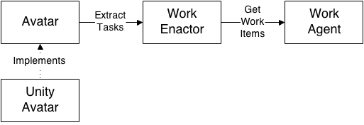

Figure 4. Relationship between Avatars, Work Enactors, and Work Agents.

As work agents are uniquely identified by their workflow ID, they are independent of their work enactor and avatar. Each work agent correlates to a participant in YAWL, but an avatar is not necessarily bound to a work agent. Work agents can be transferred between work enactors and avatars. This enables, for instance, a human to take on the role of a bot avatar, and swap back dynamically.

### Simulation Component

The Simulation Model can be broken down into its three components: Simulation, Data, and Implementation. These three components are encapsulated within distinct libraries found in the Client Simulation source code.

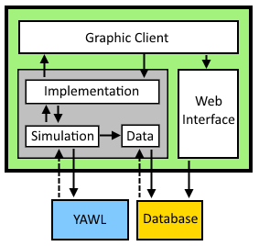

Figure 5. Client Simulation architecture elaborating on the inner Simulation Model.

The Simulation component houses all of the abstract simulation state and logic functionality.

The Simulation Component uses a Workflow Provider to track running cases, available work agents, and work items. The Workflow Provider also communicates with YAWL to start and stop cases, get details about work agents, check for delegated work items, and inform completed work items. Communication is handled in a threaded environment, sending and receiving messages off of separate threads, which necessitates appropriate data concurrency handling.

The Simulation Component tracks all of the human and bot avatars through an Avatar Manager. This entity has functions to add and remove avatars, but also to exchange avatar work agents. The Avatar Manager is responsible for ensuring that when a work agent exchange occurs, all work is transferred to the recipient avatar, and removed from the source avatar. This is important so that work items aren’t lost, nor are they completed more than once. The Avatar Manager is also responsible for tracking work agent transfers between avatars so that they can be reset.

### Data Component

The Data component provides a set of interfaces for interacting with the database. The Simulation component monitors and updates the database using the Data component. These database updates are triggered by bot avatars carrying out work item tasks; human users do not influence the database through the Simulation or Data components, rather they use the Web Interface as previously mentioned in Section 3.1.4.

### Implementation Component

The Implementation component is the platform-specific concrete implementation of the abstract simulation and avatar representations. The Implementation component initialises the simulation to be compatible with the desired platform; there are various configurable aspects such as setting an appropriate database polling frequency, and creating an entry point for a designated ‘main’ thread to call certain update procedures. This project uses the Unity main thread as the update initiator in order to circumvent some Unity threading issues (see Section 6.1.1 for more information on Unity threading issues). The Implementation component is the interface between the Graphic Client and the Simulation Component. Because the Simulation component is abstract and has no knowledge of its implementation, any updates it needs to apply to the virtual environment, such as instructing a bot to move to a location, or moving a simulation asset, are handled through the Implementation component.

### Logical Structure

The Simulation, Data, and Implementation components describe the technically segregated Simulation Model. However, as there are some overlaps in functionality, it can be beneficial to view the Simulation Model using a simplified logical structure consisting of the Avatar Manager, the Workflow Provider, and groups of services for both the database and the world state, as seen in Figure 6.

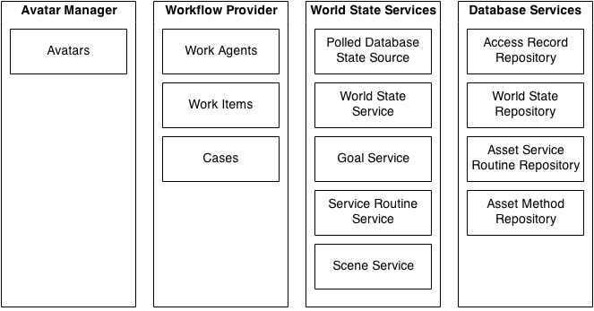

6Simulation Model logical structure.

This structure is an effective way of separating the major facets of the Simulation Model. The Avatar Manager and Workflow Provider roles have been outlined previously in Section 3.2.2. The World State services are classes dedicated to monitoring and updating the simulation world state.

The Goal Service stores world state goals that are required to complete work items, and signals work items to complete if their goals have been met.

The Service Routine Service manages asset service routines if they are present.

The Scene Service handles all eventual update messages from the simulation to the virtual environment. It is implemented to be compatible with the desired platform.

## Simulation Process

The contents of this section were previously found under 3.4 Simulation Model in the last version of this document. They’ve been moved from the old Section 3 Implementation to the new Section 3 Technical Overview because it was deemed relevant to any implementation.

This section describes the inner workings of the Simulation Model, including the interval update process, and the process for moving assets in the virtual environment via asset service routines.

Changes since the previous version include diagram and description revisions for accuracy, additional diagrams and descriptions for greater clarity.

### Simulation Update

The simulation checks for updates to the world state that need to be applied to the virtual environment at small intervals. If any updates are found the necessary services are notified, as in Figure 7 and Figure 8.

The update process is initiated by the Polled Database State Source; it doesn’t actually query the state of every asset, it only checks for database access entries more recent than the previous update time. The interval frequency is configured in the Implementation component; currently it is set at two seconds.

The World State Service subscribes to the Polled Database State Source to receive notifications about the database being updated. On an update event the World State Service triggers its own notification event for subsequent services to subscribe to, such as the Goal Service and the Service Routine Service.

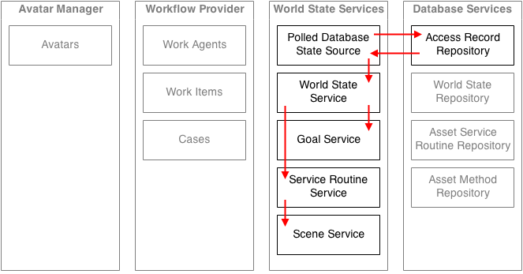

Figure 7. High level simulation update process.

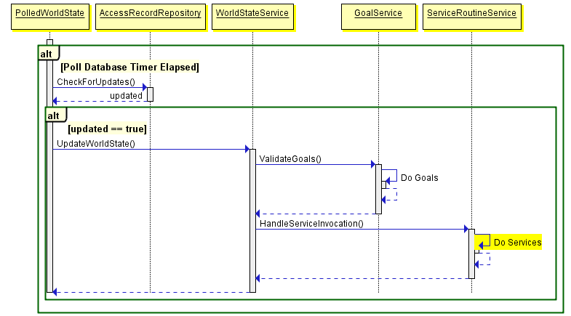

Figure 8. Simulation update process sequence diagram.

### Work Item Process

Work items are received by the Workflow Provider when it queries YAWL for any that have been assigned to participants. Work items are stored with the work agent that corresponds to the YAWL participant. When a work item is added to a work agent, the work agent decomposes the work item’s goals and registers them with the Goal Service to await completion; see Figure 9.

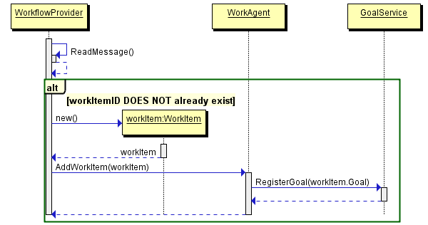

Figure 9. Process of receiving work items from YAWL.

Work item completion is overseen by the Goal Service. The Goal Service subscribes to the World State Service. On a world state update notification it checks every registered goal against its asset’s current world state to see if the goal has been satisfied. If the goal has been satisfied it signals its corresponding work item to complete; see Figure 10.

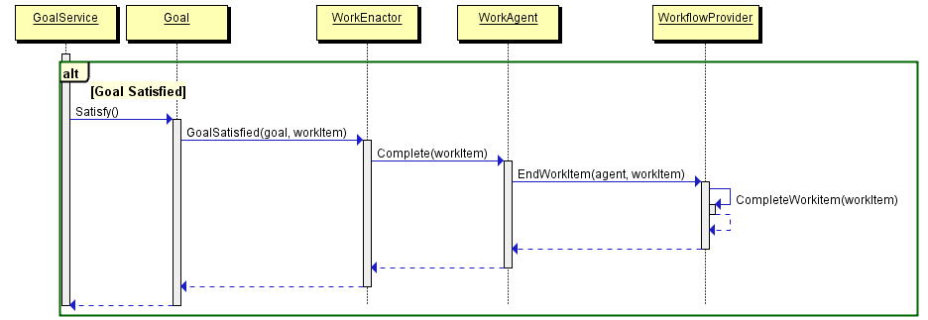

Figure 10. Process of completing a work item.

When a work item is completed the Workflow Provider sends a message to YAWL via the YAWL Relay. The work item hasn’t actually been removed from the work agent or the simulation at this point. The YAWL Relay passes the work item back to YAWL for completion, and if it receives a successful completion message it will send a response back to the simulation letting it know that the work item has in fact ended. Only then is a work item cleared from its work agent and the simulation; see Figure 11.

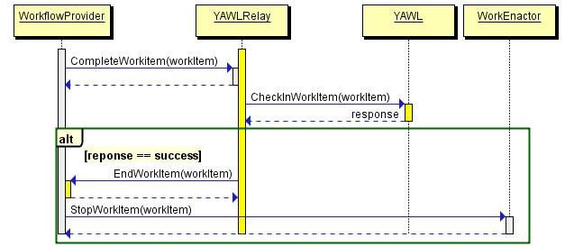

Figure 11. Process of removing a work item from the simulation.

### Asset Movement

Asset Service Routines are mechanisms for affecting objects in the virtual environment. They are inserted into the world state database when an asset is interacted with, and read again when the simulation detects a database update.

The Service Routine Service also subscribes to the World State Service. On a world state update notification it checks for asset service routines in the world state database. If any are found it delegates each to an appropriate Service Invocation Handler, such as the Move Object Handler, to be decomposed and applied to the virtual environment via the Scene Service; see Figure 12.

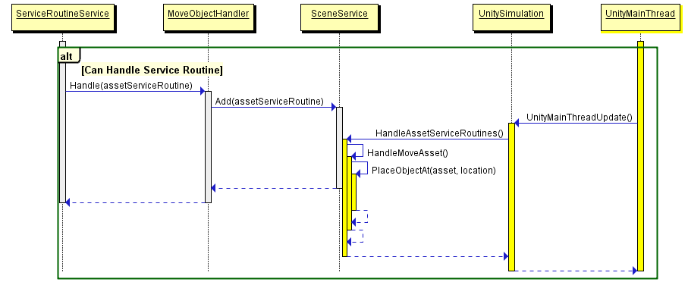

Figure 12. Process of handling asset service routines including the invocation by the Unity main thread.

At the moment the Move Object Handler is the only asset service routine handler, though it isn’t currently a problem as asset service routines are only being used to move assets. It is important to note the involvement of the Unity main thread. Due to Unity threading issues (see Section 6.1.1) service routines cannot be carried out immediately upon detection; they must be handed to the Scene Service, which is a Unity-specific implementation, to be invoked at a later time on the Unity main thread.

## Bot Work Agents

Bot Work Agents are the system that the database controls to delegate the work items to the bots in Unity. The Unity Simulator processes each Avatar that is available in the scene which then is updated to do each of their work.

### Work Cases

The Bot work cases are all processed in the BotAvatar script. The implementation is designed to abstract out the general actions that a bot can do from Veis. The abstraction allows for future implementation of YAWL in other engines to have similar methods as Unity does.

In Unity, a separate UnityBotAvatar script conducts all the available actions a bot can do. In the environment a navAgent script is implemented to each of the Avatars. The navAgent script controls all the actions an Avatar can take, regardless of whether they are human controlled or bot controlled.

Figure 13 A Standard Flow Diagram of the Bot Work Agent

### Work Agent Process

Figure 4 represents the standard flow diagram of how the bot accesses the work case and acts on it. The Bot Enactor gets the work case from YAWL Simulator, which is then passed to the BotAvatar/UnityBotAvatar. The BotAvatar passes the target asset and the parameters as a string which the navAgent gets and checks the state of the bot depending on the work case given.

Currently only Walking and Idle animation have been added to the Bot Avatar. The user can access the Locomotion component in Unity to create more Animations, and then execute those animations by the Check State method that has been implemented in the navAgent.

Any interaction between the Bot Avatar and the Assets in the scene are mainly called through the Service routine.

# Implementation

This section details the simulation application that has been implemented using Unity.

Changes in this version of the document include the new Scope for the new implementation, the introduction of bot work agents with avatars, animations, and pathfinding, and the new interaction paradigm that lets human users participate by assuming control of bots.

## Scope

This implementation was scoped to update the virtual environment’s aesthetic, and add a small number of important features, primarily concerning proper bot work agents being able to work in conjunction with human users.

The environment was to be redecorated with appropriate textures and models to better resemble a real-life hospital. Proper avatars were to be added that better resemble hospital staff. The avatars also needed appropriate animations and pathfinding to move around the environment in a believable manner.

Bot work agents were to be added that could be delegated work items that they would complete autonomously, and simultaneously. These bots would need to be able to reliably complete the hospital case without human management. The bots would need to be able to affect simulation assets in the same way that humans do: updating the asset’s world state in the database, and moving the asset if applicable.

Bots also needed to be able to defer control to a human user. A human user needed to be able to take control of any bot and assume its role in the workflow, starting work on its current work item. The human user also needed to be able to transfer control of the avatar back to the bot, such that the bot would then resume the current work item assigned to the role. The human could then take control of another bot if desired. These events needed to happen reliably, dynamically, and without disrupting any aspect of the workflow.

## 6Avatars

A Nurse avatar has been implemented in the unity scene.



Figure 14 Nurse Avatar

The nurse avatar replaces the capsule controllers from the previous implementation. Currently, as a nurse model is the only model available, a texture swap is used to differentiate the model between the nurse and the doctor.

The nurse model’s animation is set up with Mecanim. Mecanim is Unity’s animation system to blend different sets of animation together so that they transition smoothly. Mecanim’s feature allows it to compliment well with the navigation agent that is also added to the avatar.

The avatars are instantiated in the middle of the Emergency Room near the best, similar to the previous position of the Capsules.

## Animation and Mecanim

Mecanim is Unity’s implementation of Animation system. Mecanim allows for quick character setup and sophisticated Animation Set-up. This section will briefly touch on how to add Animations onto the Avatar and it’s locomotion set-up. Deeper understanding of Mecanim can be found using the Unity Manual.



Figure 15 Mecanim Animation Tree

Mecanim Animation Tree, as seen in Figure 8, cycles through different sets of animation depending on the Parameters. States and Blend Tree can be added on the map to add an additional set of animation. States are used for Animations that is dictates by a single animation set. (Standing, Sitting) Blend Trees are used for Animation sets that utilises similar set of animations that are required to blend together for better presentation. (Walking, Walking left, walking right)

Once the animations are set up, The States are connected to a parent state/blend tree via a transition. The transition sets the condition on how to invoke that particular set of animation.

## Environment

The environment resembles a hospital containing the rooms required by the asset specifications: the Emergency Room, Examination Room, Intensive Care, Radiology Room, and a final unnamed room (see Figure 16). The map in Figure 8 is still relevant in a way that the general layout remains the same, however the new layout has some differences to take note.

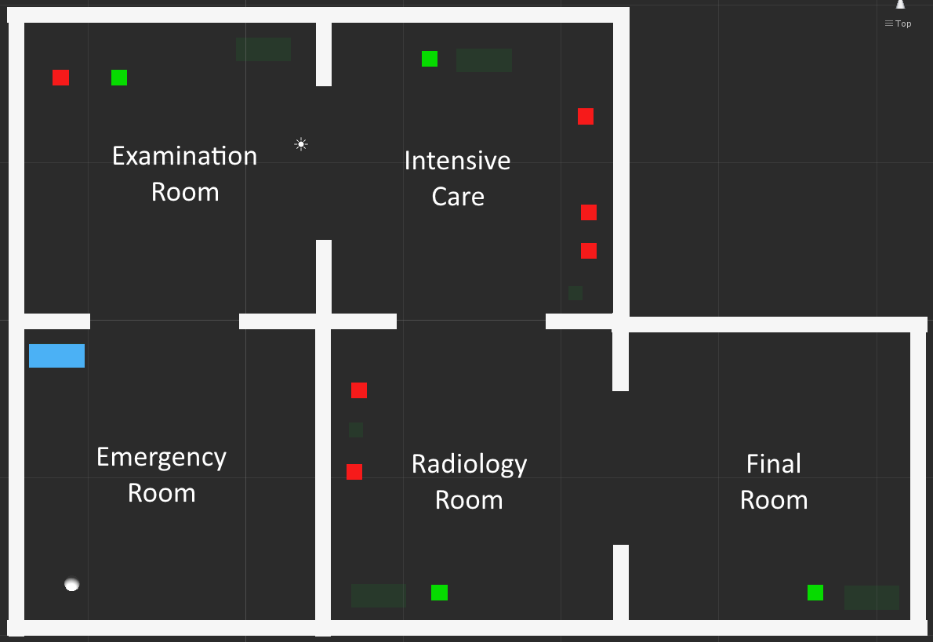

Figure 16. The Unity application environment Layout.

The new implementation replaced a lot of the green and red placeholder boxes with actual assets, however environmental assets that aren’t tied to the database are also added. While most of them are purely cosmetic at the moment, they could potentially be added to the database for additional features.

The only asset that are relevant to YAWL that is left unchanged are the Blood Vials, as there weren’t any 3D Models available to use for them.

Texture and Multiple Lighting Systems are added in the environment. While there are multiple lights lighting a room, only 1 point light in the centre of the room casts a shadow, for a cleaner and less resource hogging solution.



Figure 17. The udpated map.

## Navigation Mesh

The major change from the previous iteration compared to the previous version is the user interaction toward the Avatars. The current version uses mouse controls exclusively instead of using keyboard bindings.

Using the mouse to direct the Avatars instead of using the keyboard requires the Avatars to have a Navigation Mesh.



Figure 18 Navigation Mesh in the Scene

In Figure 10, the blue areas are the navigation mesh that has been baked into the Unity environment scene. A navigation agent cannot traverse any area outside of the blue area. The navigation mesh can be rebaked and modified in the navigation tab in Unity. You can assign static options to any mesh in the scene that the navigation mesh shouldn’t traverse over, and re-bake the mesh. There are other options that can be modified, but in this case the radius is the only relevant option in the Simulation, as it controls the radius around the agent that it doesn’t pass.



Figure 19 Options for Baking NavMesh

## NavMesh Component

The NavMesh Agent is a component that is applied to the Avatar that implements their pathfinding AI. The Component class comes with a number of functions, but the main one to use is the SetDestination, that targets a point in the Navigation Mesh for the Avatar to traverse.

The NavMesh Component comes with a few options:



The radius is the buffer that the avatar places to determine the path. Speed and Acceleration adjust how fast the avatar traverses, and the Angular Speed determines how fast it turns. The stopping distance adjusts the offset distance from the point the traversal stops. All the variables can be adjusted via script.

## Graphic User Interface

Figure 20 shows the Graphic User Interface (GUI) as seen by the user. The user sees the hospital environment and their avatar in the third person. Figure 21The new implementation removes 3 buttons in the bottom left corner, and adds a camera option GUI on the top right.



Figure 20 The GUI: When the Camera is following Janie May



Figure 21. The Simulation controls available to the user.



Figure 22. Case and work item information remains the same.



Figure 23. Floating labels for asset identification.

## Simulation Control

The Simulation controls previously shown in Figure 21 are used to get the Simulation going.

The Reset Simulation button just sets Simulation variables to their initial values. This affects local data tracking like registered participants and current work items; it does not affect externally stored data like asset states and work item states, which are stored in the database and YAWL respectively. The Start Simulation button is currently redundant because when the Simulation resets it performs that function as well.

The Register as Participant button assigns a case participant to the user’s avatar. In this implementation there is only one case participant so the user is not able to make a selection. There is currently no way to unregister from being a participant.

The Launch Case button notifies YAWL to start the case, which is also sent back and stored in the Simulation.

The End All Cases button notifies YAWL to end any running case. This only ends locally tracked cases; it does not end cases that might have been started in YAWL outside of the Simulation.

## Asset Interaction

Assets in the environment can be interacted with by clicking on them. This will launch the Asset Interaction Web Interface (see Figure 24) which uses asset details to load its state and available methods. The Asset Interaction Web Interface is the only way the user can affect asset states. It directly updates the World State database, which is then read by the Simulation Model. It updates asset values and inserts asset service routines if an action needs to be performed on an asset, such as moving it.

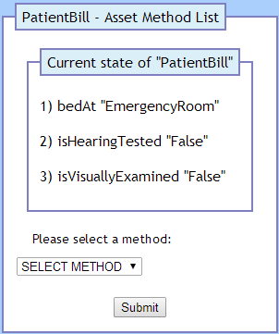

Figure 24. The first page of the Asset Interaction Web Interface.

## Changing control as a Bot to Human



In the Unity Inspector, you can determine who is in control of the Avatar by looking at their control status. By default the avatars control status are set as Bot.

At any point in the simulation, the player can take over control of an Avatar in the scene, by simply clicking over their Avatar.



You can see from this screenshot that the ID as a player have changed, so that Janie May has the original ID of the player, while Ross Brown who you are, takes over the ID of Janie May. After the control is shifted, the player can choose to complete the work cases themselves, using the Demonstration in the previous section.



You can observe from this that the control status has switched to Human, which allows the user to interact the environment using this avatar.

If you wish to give back control of the avatar back to the bot, you simple press the Release Bot button on the Top Right corner to revert all ID back to their respective users.



# Execution

This section has been completely changed to illustrate the most recent implementation. With the introduction of multiple avatars and bots several new features will be demonstrated, including: avatars working simultaneously on a branching workflow, bots completing work items autonomously, and humans completing work items by dynamically taking control of bots.

This section demonstrates the completeness of the Unity application implementation. The demonstration assumes the following preconditions:

* An appropriate webserver is being hosted locally with MySQL and PHP
* The necessary MySQL database has been set up
* The YAWL Web Service is running
* The necessary hospital case specification has been loaded
* The YAWL Relay is running

## Relevant Interface Overview

In this version the YAWL Relay replaces the old Veis Java Socket Server.

This section explains any other relevant interfaces that will be shown.

### YAWL Relay Console Interface

Figure 25 shows the console interface for the YAWL Relay. As this application passes messages between the Simulation and YAWL it also prints some information to this console interface for human viewing. This interface will be used to confirm some state changes as they are communicated between the Simulation and YAWL.

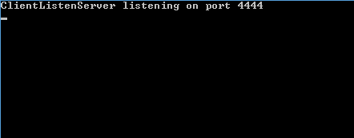

Figure 25. YAWL Relay console window immediately after it is executed.

### YAWL Web Interface

Figure 26 shows the Cases tab in the YAWL Web Interface. Here, case specifications can be loaded, cases can be launched, and running cases can be viewed or cancelled. This interface will be used to confirm that cases are running or not.

Figure 27 shows the Admin Queues tab and the Worklisted sub-tab in the YAWL Web Interface. Here, work items that are being handled by YAWL can be monitored. This interface will be used to confirm the state of various work items.

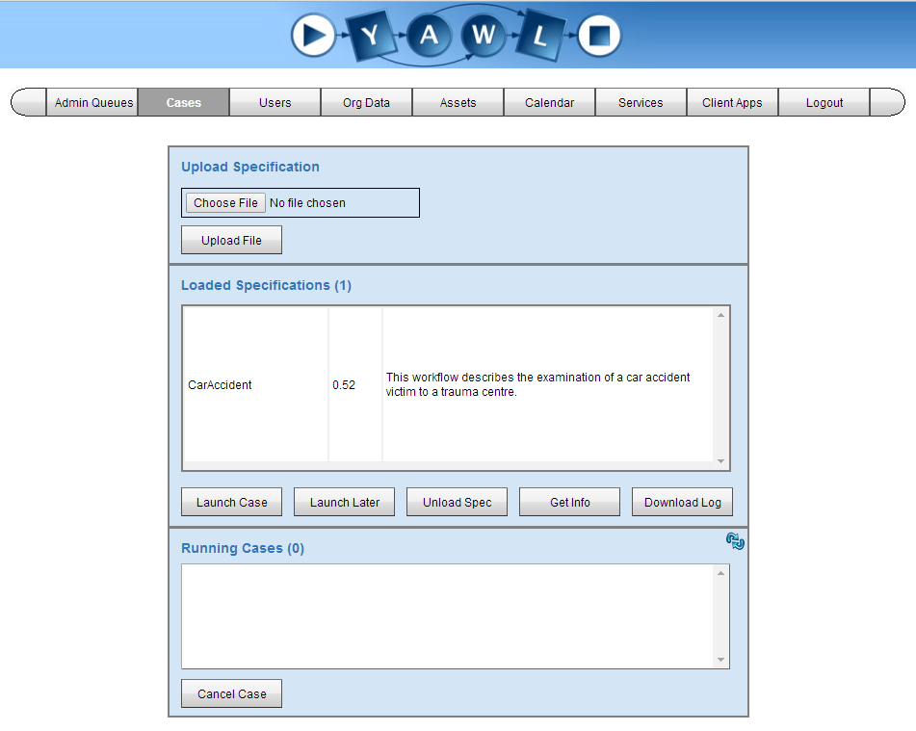

Figure 26. YAWL web interface view of case management section with no case running

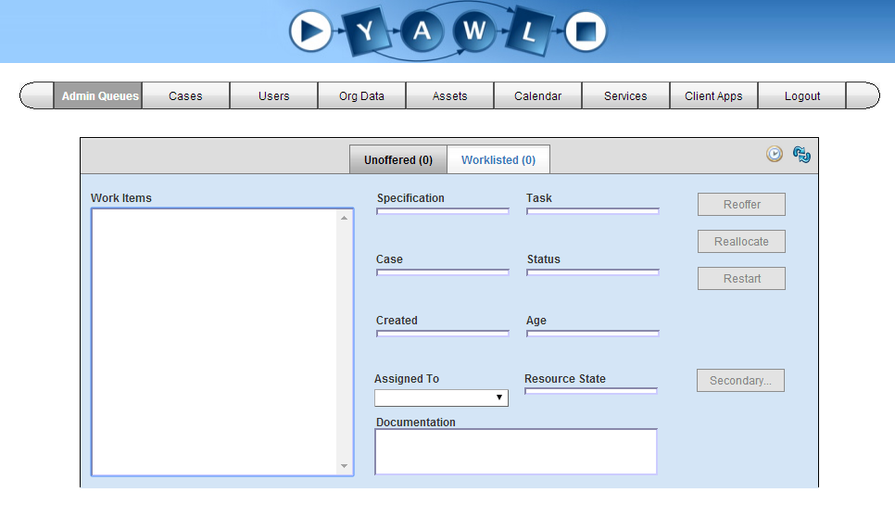

Figure 27. YAWL web interface view of current work items with no case running

### World State Table View

Figure 28 Shows a view of the World State table, part of the Veis MySQL database, accessed through the PHPMyAdmin Web Interface. Simulation assets are defined in the Knowledge Base, and the World State stores various current states for those assets. This view will be shown to confirm the state of assets. Note that some of the assets listed in this table are not relevant to this simulation.

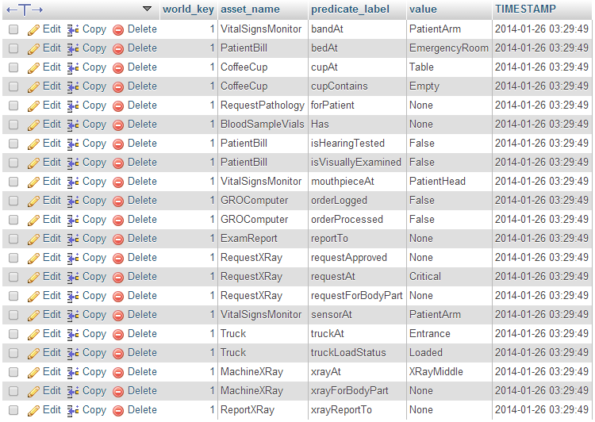

Figure 28. MySQL database table view of asset world states with its initial values

### Asset Service Routine Table View

Figure 29 shows a view of the Asset Service Routines table. This table holds actions to be performed on assets such as moving to a new position. The actions are handled directly by the Simulation and then removed; as such the table is usually empty.



Figure 29. MySQL database table view of asset service routines.

### Case Diagram

Figure 30 shows the work items that make up the case workflow specification as viewed by the YAWL specification editor. The double-layered box indicates a sub-net containing more work items. Colour has been added to work items to indicate which role(s) they can be assigned to; purple for the doctor role and pink for the nurse role.

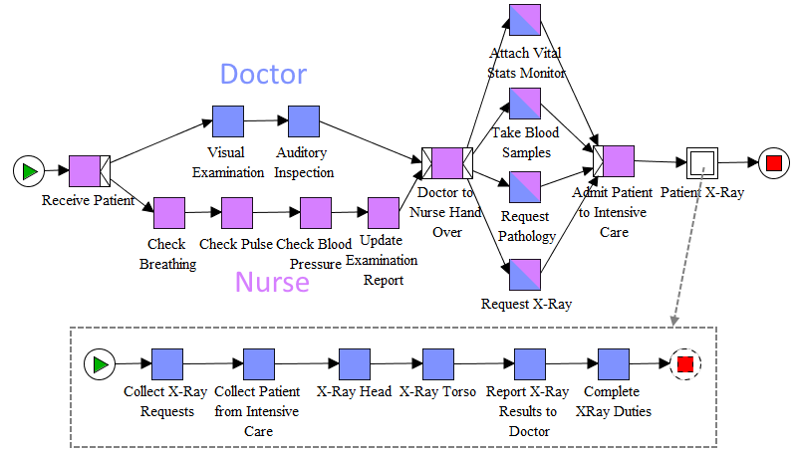

Figure 30. The case workflow specification. The double layered box indicates a sub-net.

## Starting the Simulation

When the Unity application starts the virtual environment is created and the simulation is initialised. The world state for every asset is set to its default values (see Figure 27). A connection is established with the YAWL Relay, which is immediately queried for details about the case, as well as participating agents and their roles (see Figure 31). For each participating agent a client-side work agent is created to hold its work items, and an avatar is instantiated as its physical representation in the scene (see Figure 32). A human user named Ross Brown is also created (see Figure 33), though it is not visible in the scene because humans do not have their own physical entity, rather they control bot avatars to do work. The user’s camera view begins as the default spectator perspective.



Figure 31. A connection is established with the YAWL Relay and initial case information is requested.



Figure 32. A bot is created for each agent participating in the case.

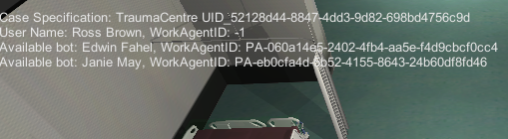

Figure 33. Bot work agents and a single human user.

The simulation doesn’t start processing until the human user presses the Start Simulation button in the lower left (see Figure 34). This triggers the simulation to send a request to launch the case (see Figure 35). If the case launch is successful the YAWL Relay responds to the simulation with the started case (see Figure 36).

Note that the human user may or may not be in control of a bot at this time; it does not affect the start of the simulation in any way. In this case the human user is not controlling a bot, as evidenced by the special WorkAgentID of -1 assigned to Ross Brown that is used to be ignored by the Workflow Provider (see Figure 36).

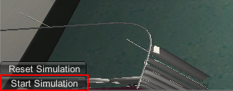

Figure 34. The simulation does not start processing until Start Simulation is pressed.



Figure 35. The YAWL Relay receiving a request to launch a case, and sending the started case response.

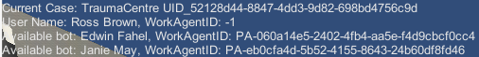

Figure 36. The simulation has received details about the started case.

## Bots Working Autonomously

Once the case has been launched the simulation will request the work queues of each of the participants (see Figure 37). Any work items that have been assigned on YAWL are communicated back to the simulation where they are assigned to the corresponding work agent. The first work item is Receive_Patient (see Figure 38 and Figure 39). The simulation passes this work item to the work agent for Janie May, who decomposes the work item’s goal to generate the required tasks to complete the goal (see Figure 40).

Janie May’s first work item involves moving the asset PatientBill to the location ExaminationRoom. The first task that needs to be completed is actually the WALKTO task, which specifies the asset in the environment that the avatar needs to navigate to in order to interact with it (see Figure 41); it is not shown in the task queue because it is consumed too quickly to be captured. The ASSETINTERACTION task specifies the predicate and value that need to be set for this asset in the world state database. The ASSETSERVICEROUTINE task specifies an asset service routine that needs to be inserted in the asset service routine table in the world state database. The ANIMATE task is presently a placeholder for issuing work-specific animations.

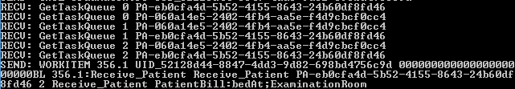

Figure 37. The YAWL Relay handling requests for participant work queues.

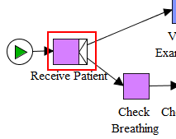

Figure 38. The first work item specified in the case diagram.

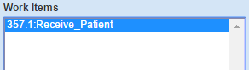

Figure 39. The first work item delegated by YAWL.

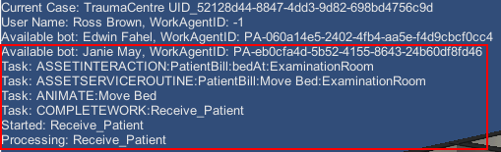

Figure 40. The work agent for Janie May with a work item and its decomposed tasks.



Figure 41. The first decomposed task for the work item Receive_Patient.

The avatar moves to the PatientBill asset and completes its interaction, leaving its task queue empty (see Figure 42). The world state database has been updated so that PatientBill has the predicate bedAt set to ExaminationRoom (see Figure 43). An asset service routine has been inserted to actually move the asset in the environment (see Figure 44).

The work item is not officially completed at this point; the simulation checks the work item back in to YAWL (see Figure 45, the yellow box) and, if the check in is successful, a response is received signalling that the work item should finally be removed from the simulation (see Figure 45, the blue box). The YAWL Web Interface confirms that the work item has been removed and replaced with a new one (see Figure 46).

The PatientBill asset does not move instantly; as explained previously in Section 3.3.3 the asset’s service routine will not be detected until the world state update timer has elapsed. Once that happens the asset will be moved to the location specified in the asset service routine (see Figure 47).

This is the process by which bot work agents complete all work items. For the sake of brevity the same detail will not be shown for every instance of a bot completing a work item.

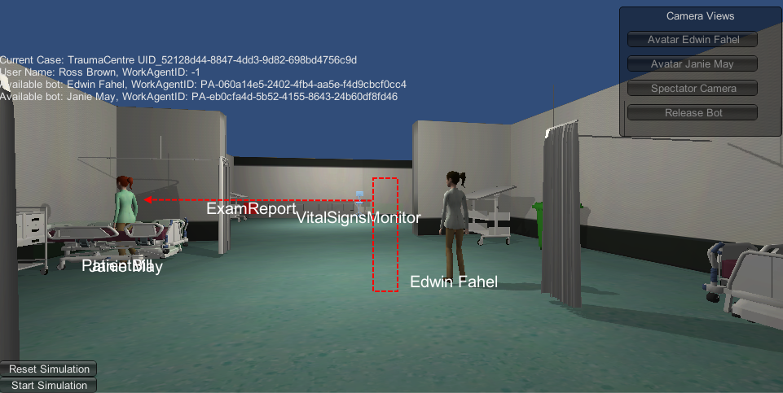

Figure 42. The avatar has moved to the asset location.

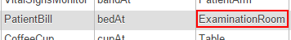

Figure 43. The world state value bedAt for the asset PatientBill has been updated to ExaminationRoom.

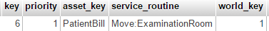

Figure 44. An asset service routine has been inserted to move PatientBill to ExaminationRoom.



Figure 45. The YAWL Relay sending a work item, receiving a notice that it has been completed, and sending a response to remove it from the simulation.

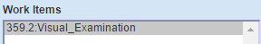

Figure 46. The Receive_Patient work item has been removed from the YAWL Web Interface and replaced by a new work item.

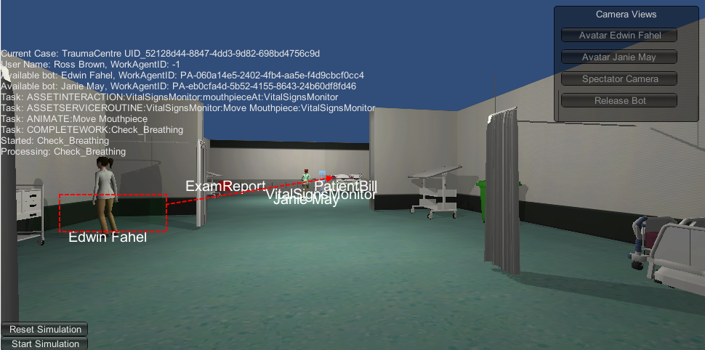

Figure 47. The PatientBill asset has been moved to ExaminationRoom by an asset service routine.

## Branching Workflows

To utilise the presence of multiple avatars effectively the case specification was updated to distribute work items to both the nurse and the doctor roles. There are now instances where both roles can complete work simultaneously; the first being immediately after the first work item (see Figure 48).

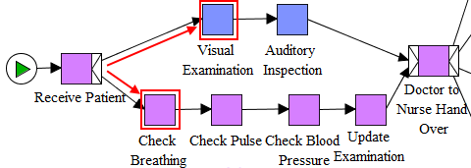

Figure 48. After the first work item the workflow branches to both the nurse and doctor roles.

The YAWL Web Interface shows both work items have been assigned (see Figure 49). The simulation has successfully received both work items and assigned them to their corresponding work agents (see Figure 50). The doctor moves to the PatientBill asset to do more inspections, and the nurse moves to the VitalSignsMonitor to do tests involving sensors (see Figure 52). Both avatars continue to complete their work items (see Figure 52).

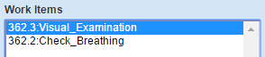

Figure 49. The YAWL Web Interface shows two work items in a branching workflow.

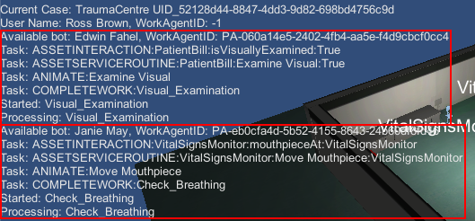

Figure 50. Both work agents have a work item assigned to them that they are processing.

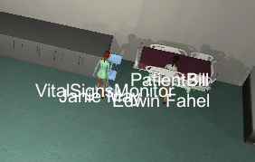

Figure 51. The nurse working with the VitalSignsMonitor and the doctor working with PatientBill.



Figure 52. Both the nurse and doctor work agents completing work items simultaneously.

To conclusively demonstrate that both of the work agents completed their branches the work item that joins the two branches together (see Figure 53) must be completed. After the work agents have completed their branches the Doctor_to_Nurse_Hand_Over work item is delegated (see Figure 54 and Figure 55), and the nurse completes the work item, updating the asset’s world state (see Figure 56) and moving PatientBill to IntensiveCare (see Figure 57). The YAWL Web Interface shows that the work item has been successfully completed, and replaced by the next branching work items (see Figure 58).

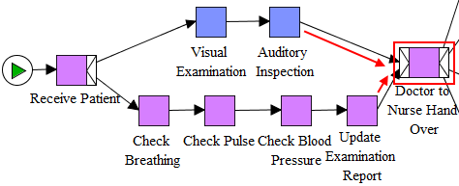

Figure 53. This work item requires the two branches that join onto it are completed.

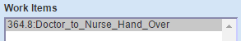

Figure 54. The YAWL Web Interface shows the Doctor_to_Nurse_Hand_Over work item has been assigned.

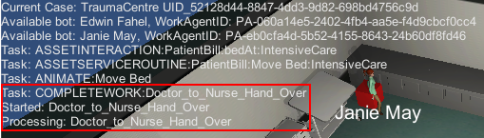

Figure 55. The avatar's queues show the Doctor_to_Nurse_Hand_Over is received.

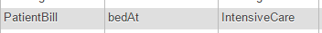

Figure 56. The PatientBill asset's world state has been updated.

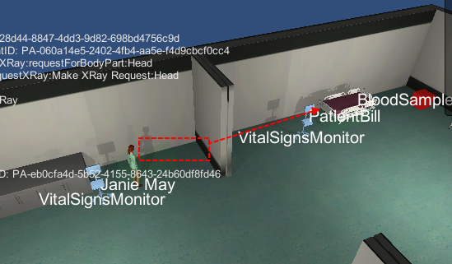

Figure 57. The PatientBill asset has been moved to the IntensiveCare location.

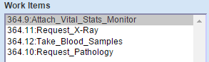

Figure 58. The YAWL Web Interface showing the Doctor_to_Nurse_Hand_Over work item has been completed.

## Human Participation

As detailed previously in Section 4.10 humans take control of avatars to participate in the simulation. Humans can take control of any avatar at any stage, whether the simulation is running or not. At this point in this instance of the simulation the human has not yet taken control of any avatar. This section will now demonstrate the process of taking over an avatar, swapping between avatars, and relinquishing control of avatars.

The workflow has branched again into four parallel tasks that can be assigned to either the nurse or the doctor (see Figure 59). The work agent task queues indicate that the doctor has been assigned three work items and the nurse have been assigned one (see Figure 60).

The human clicks on the doctor to take control of the avatar, exchanging their work agent IDs to direct work items to the human rather than the doctor (see Figure 61). Now that Ross Brown has been given the doctor’s work item, the task queue is no longer needed because the human can guide the avatar to complete the work item goals. At this point the doctor had already completed one of the work items, and the nurse had completed its work item. The nurse it will be assigned the work item immediately after the branches join, so it is now waiting for the human to complete its remaining work items.

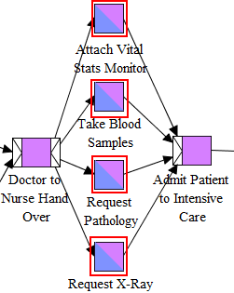

Figure 59. The workflow branching into four parallel tasks that can be assigned to either a doctor or a nurse.

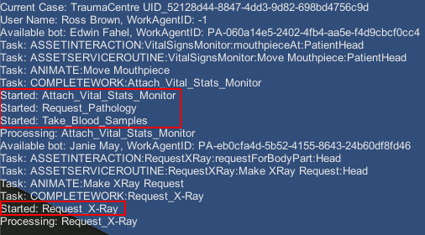

Figure 60. The work agent task queues showing the distribution of four parallel tasks.

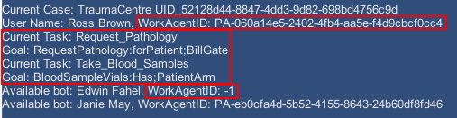

Figure 61. The human user has taken control of the doctor avatar, exchanging their work agent IDs.

The human user interacts with the RequestPathology asset through the Asset Interaction Web Interface (see Figure 62). The asset’s world state is updated in accordance with the value entered from the interaction (see Figure 63). The human completes the Take_Blood_Samples work item and the nurse can be assigned the next work item(see Figure 64). Once the nurse has completed that work item the remaining work items are for the doctor (see Figure 29).

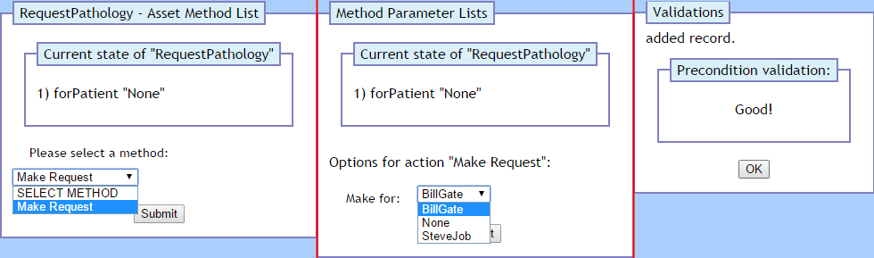

Figure 62. The human user interacts with the RequestPathology asset via the Asset Interaction Web Interface.

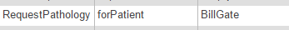

Figure 63. The human user has affected the world state of the RequestPathology asset.

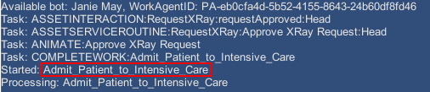

Figure 64. The nurse work agent is assigned its next work item after the human user has completed all of its parallel work items.

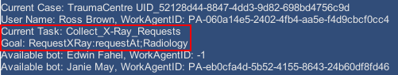

Figure 65. The human user is assigned the next work item.

The remaining work items can now be completed using the same process as for RequestPathology. However, to demonstrate that human users can also move assets, Ross Brown will complete the Collect_Patient_from_Intensive_Care work item (see Figure 66). Once again using the Asset Interaction Web Interface the human user satisfies the world state condition for the work item (see Figure 67), which inserts the necessary asset service routine (see Figure 68), which moves PatientBill to RadiologyRoom (see Figure 69). The human user could continue with the case, or swap control to the nurse avatar; for now they decide to release the avatar, handing its control back to its original bot work agent (see Figure 70). The bot work agent now resumes its work as though nothing had happened.

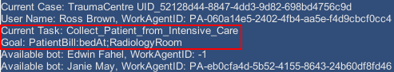

Figure 66. The human user has a work item that moves the PatientBill asset.

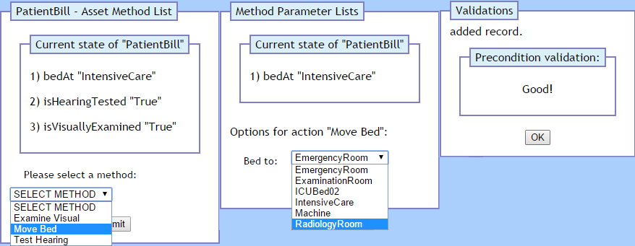

Figure 67. The human user ineracts with PatientBill to move it to RadiologyRoom.



Figure 68. The human user has inserted an asset service routine to move PatientBill to RadiologyRoom.

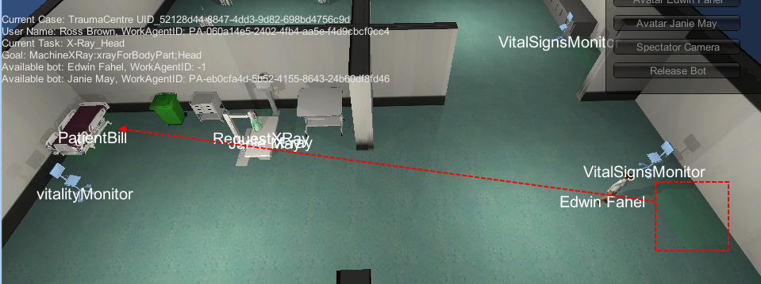

Figure 69. PatientBill has been moved back to RadiologyRoom by the human user.

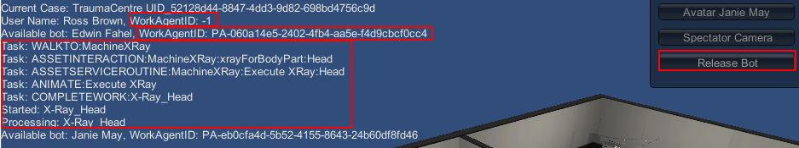

Figure 70. The human user relinquishes control of the doctor, and the doctor resumes its work.

## Completing the Simulation

The last work item for the case is to move PatientBill to the ICU (see Figure 71). No more work items have been assigned to any of the work agents (see Figure 72). The YAWL Relay has checked in the last work item; when it detected that the case was no longer active it notified the simulation that it had ended (see Figure 73). The simulation successfully receives the signal to end the case (see Figure 74). The YAWL Web Interface confirms that the case is no longer active (see Figure 75).



Figure 71. PatientBill has been moved to the ICU.

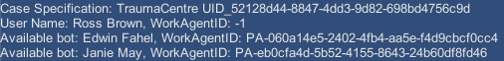

Figure 72. No work agents have any work items.

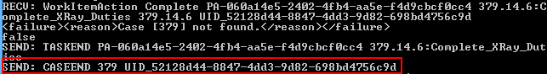

Figure 73. The YAWL Relay checked in the last work item, and upon finding no case, notified the simulation that it had ended.

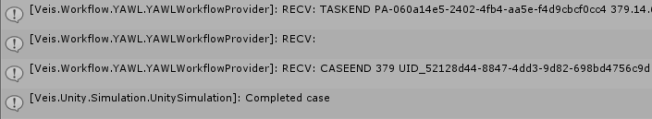

Figure 74. The simulation has received the signal that the case has officially ended.

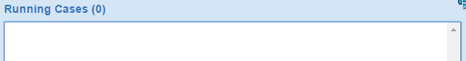

Figure 75. The YAWL Web Interface confirms that the case is no longer running.



Figure 76. Comparison between the initial and final asset world state database values.

# KNOWN ISSUES

This section lists notable technical issues and, where possible, potential solutions to those issues. Some of the issues may have been updated as more was learned about them. Some of them may have been resolved, or even avoided in order to continue the implementation, though if they could arise again they have been marked as [Legacy].

## Issues Specific to this Implementation

These are issues that are present due to the project being implemented in Unity.

In this version the issue regarding Unity DLL conflicts has been overcome but left as a legacy issue as it may be a problem in future if more libraries are imported.

### Unity Type Threading Issues

Unity reference Types such as Transform are not thread-safe and can only be accessed from the main application thread. This has already caused issues with some of the simulation architecture due to its use of threads (see Figure 77. Unity Types and methods cannot be accessed from outside of the main thread.); specifically, the Simulation updates the game world via the SceneService on a System.Timers.Timer, which raises events and is handled on a Thread Pool thread (not the main thread) [Microsoft 2014]. When the timer thread attempts to interact with Unity objects it breaks.

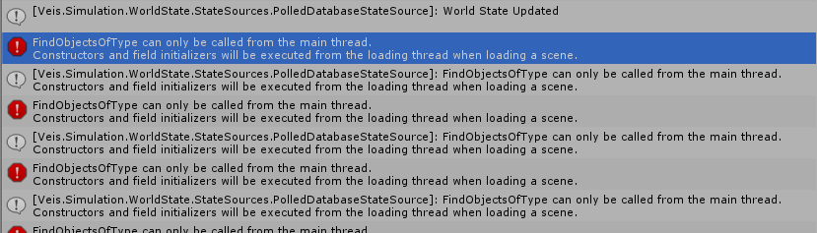

Figure 77. Unity Types and methods cannot be accessed from outside of the main thread.

Two methods have been realised to somewhat overcome this issue: inserting a main thread entry point into the simulation with which to invoke unsafe processes, and using a Producer-Consumer pattern when necessary. The timer thread queues instructions in the SceneService, and the main thread periodically checks and executes those instructions. Unfortunately as timers cannot be used due to their threaded nature the only way to get the main thread specifically to perform the actions is to have the call come from an Update method off a script in the Unity scene. While the application does execute properly the tight coupling with the Unity scene is undesirable, and it is unknown how effective these solutions will be as the project continues to grow.

For ease of use a dedicated static class has been added to the Implementation component called ThreadedActionHandler. This class stores a System.Action queue that is iterated over every Unity Update, where all actions in the queue are invoked. Storing generic actions allows many statements to be inserted as a single action, nearly as easily as calling a normal method or using a LINQ statement. Being static, actions can be added from anywhere in the Implementation component. One caveat being that the actions are handled asynchronous to the sections of code that insert them; actions cannot be expected to execute within their local code blocks.

### Unity DLL Conflicts [Legacy]

The libraries referenced by the Veis, Veis.Data, and Spark DLLs cause errors with the Unity compiler (see Figure 78 and Figure 79). The Unity compiler output file indicates that the problem arises because these DLLs reference system libraries that are not supported by Unity (see Figure 79). The errors can be subdued by manually including the specific system libraries (see Figure 81). However, the manual inclusion of system libraries can cause conflicts with their Unity version counterparts when trying to use some Types (see Figure 82). The project will compile and run if no conflicting Types are used, but that removes access to some useful Types, for example System.Timers.Timer. One possible solution to these problems which stem from mismatched system references might be to recompile the Veis DLLs using the Unity versions of the necessary system libraries.

This issue has been overcome since the previous version. Veis and Veis.Data are being used as non-compiled code. Libraries such as Spark, however, are only available as compiled DLLs; unfortunately there may not be any way to resolve their incompatibilities with the Unity compiler.

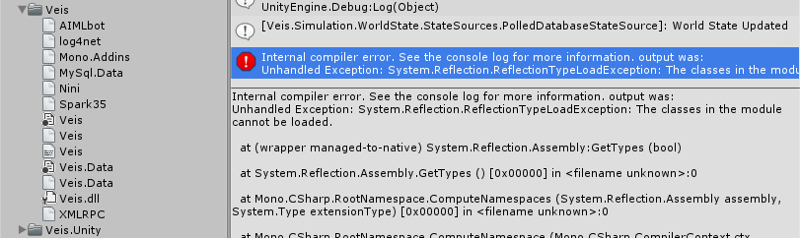

Figure 78. The Veis DLLs and their dependencies, and the error shown when Unity tries to compile them.

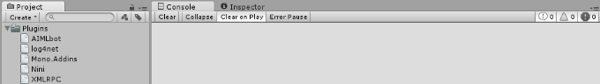

Figure 79. The Unity project will compile when the Veis, Veis.Data, and Spark DLLs have been removed.

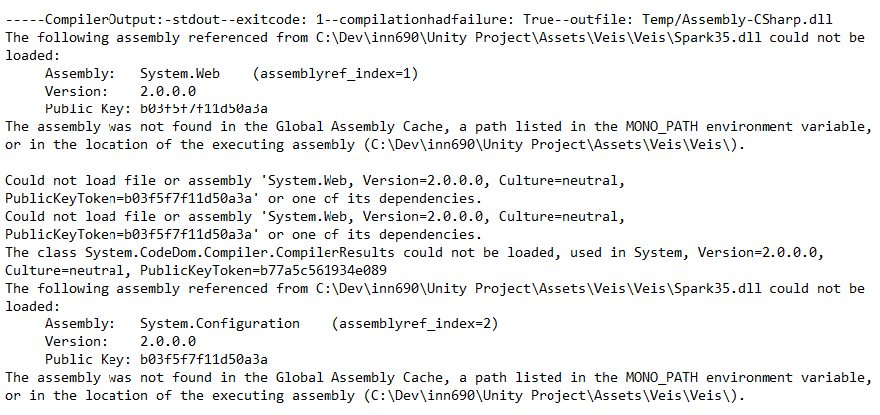

Figure 80. The Unity Editor log indicates that some of the Veis DLLs reference system libraries not supported by Unity.

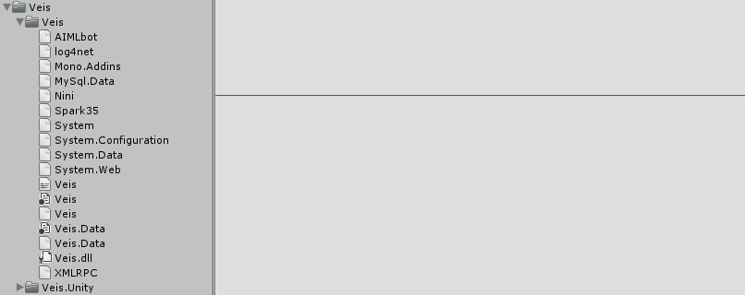

Figure 81. The Unity project will compile without error if the error-inducing system references are manually included.



Figure 82. The Unity Editor will not compile when a Type is used that is contained in a system library that has both a Unity and non-Unity version present.

## Issues Not Specific to this Implementation

These are issues that were either present prior to this implementation or have not presented themselves due to the project being implemented in Unity.

Changes in this version include: fix of the issue World State Reset Not Automated; fix of the issue regarding the Socket Server being computationally intensive, as it has been replaced by the YAWL Relay; the addition of the YAWL Communication Challenges issue which details the reasons why the YAWL Relay is a necessary component; the addition of the Simulation Reset Unreliable issue regarding the slightly non-deterministic state of the virtual environment after a reset.

### YAWL Communication Challenges

All of the information surrounding this issue can be sourced from the YAWL Technical Manual [The YAWL Foundation 2010], or from the YAWL forums.

YAWL is a Tomcat hosted Java web application. It is comprised of an engine and various services, the most important and useful being the Resource Service, which automates workflow delegation and resourcing.

YAWL does not expose its engine directly, so it cannot be accessed even via a bridge such as JNBridge or jni4net. All communication must be handled through web services. Unfortunately there is no web service API (WSDL/SOAP) that exposes possible remote procedures or message formats, nor is there a REST API with URL endpoints. There are only two ways to interact with YAWL: by registering a user-specified custom web service to handle work items, or by directly implementing one of the YAWL Java interfaces.

Making use of a custom web service might sound like a viable approach; in fact a custom web service was implemented, but it was ultimately abandoned. The main reason a custom web service is absolutely futile is because YAWL hands work to a single service only. Keep in mind that the Resource Service, being a web service, is the default work handler; if the Resource Service does not handle the work then none of the work item delegation and assignment to participants happens. If the workflow is not handled automatically by a YAWL service then it would have to be handled manually by some custom implemented service, which would make YAWL quite useless as a workflow tool for the purposes of this project.

The only plausible method of communicating with YAWL is to use the YAWL Java package and implement its interfaces [The YAWL Foundation 2012]. This allows the implementation to register itself and call certain YAWL engine methods. Unfortunately this then necessitates a Java YAWL Relay application for the simulation to be able to interact with YAWL.

This is also the reason why the simulation needs to be checked manually YAWL for updates. YAWL is capable of notifying registered services of events such as cases being started, or work items being delegated, but once again that comes at the cost of the automated workflow management. Therefore, the only way to know the state of YAWL is to query it at strategic moments, such as when a work item has been completed. However, YAWL does not update instantly, and querying it too quickly after completing a work item will result in race conditions where its state will not have updated. This is the reason for the delay on queries such as getting new work items. The only other option is to poll at a constant interval which doesn’t actually alleviate the problem.

Presently the YAWL Relay is a simple socket-based server that reads and writes strings, which is less than ideal. It would be possible to implement the YAWL Relay as a proper Java web service (not a YAWL custom service) with a WSDL interface that the C# simulation could communicate with via SOAP messages, so as to loosen their coupling somewhat. It is suggested that this is of low priority as the communication is currently sufficient for the simulation’s purposes.

### Simulation Concurrency

While the simulation does not employ a great number of threads, it is still obviously important to ensure data integrity and avoid race conditions. Since the previous version a number of existing concurrency issues have been located and resolved, most notably involving bot task queues and work items being overwritten and corrupted. Unfortunately not all possible concurrency issues have yet been addressed. Many of these issues appear to stem from inconsistent design paradigms used throughout the simulation; object locks are used in some places, but not others; some objects seem to not have been implemented with concurrency in mind at all.

A very useful extended List<T> class has been added called ThreadSafeList. Though the implementation is rudimentary, meaning it does not manually handle iterators and other lower level technical aspects, it behaves like a normal list while being completely impervious to concurrency issues.

It is suggested that a long-term concurrency strategy is devised. The added ThreadSafeList may be useful, but it’s not a viable option for every scenario involving concurrency. It might be possible to implement numerous thread safe collections but then single objects would still require locks. In the long term it might be more appropriate to make a definite decision to either make the caller lock when needed, or to make all members private and ensure all access methods enforce locks.

### Simulation Reset Unreliable

Presently the simulation cannot be reset to its initial world state reliably. The main cause of concern is the way the simulation updates at intervals, meaning some updates may be applied to the virtual environment after the reset is triggered. An example would be an asset service routine that was inserted into the database before the reset occurred; even though the update timer is stopped until the simulation is started again, the asset service routine will still be detected at the next update, and the asset will be moved.

One possible solution would be to ensure database tables such as the asset service routine table are cleared on reset or on simulation start; this approach would require some additions to the database interface classes. Another solution would be to completely reset all of the world state database tables by executing a MySQL routine. Note that a MySQL routine is presently used to reset the asset world states within the database, but the routine does not affect tables such as the asset service routine table. It may be simpler to just update the existing routine to ensure no undesirable changes transfer between simulation runs.

### Database Missing Some Asset Methods

Many assets have methods that can be enacted upon them (see Figure 83). Some of these methods are intended to move assets between locations. When an asset is to be moved it is communicated to the Simulation via a service call (see Figure 84). The possible locations for moving assets are defined in another table (see Figure 85). However the only asset relevant to the simulation that has a service call is PatientBill. The assets MachineXRay and RequestXRay both have move methods but are lacking service calls and location values. It is unclear whether these assets have not had these values entered yet, or whether they were actually not intended to be moved. The current solution has been to place these assets wherever they are needed.

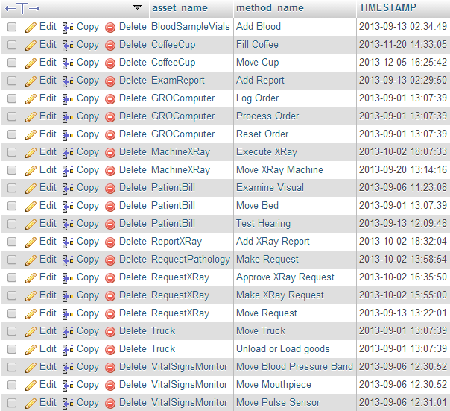

Figure 83. Methods that can be enacted upon assets.

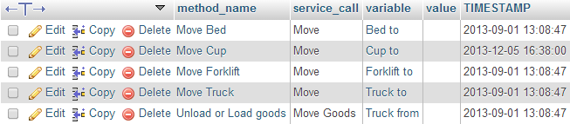

Figure 84. Services to be called when an asset method is to be enacted.

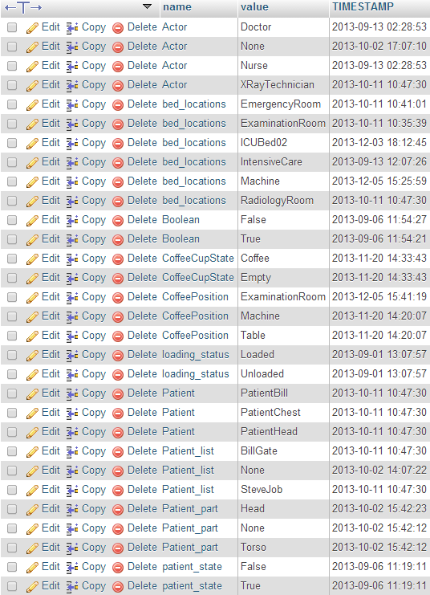

Figure 85. Possible values that asset predicate labels can be assigned.

# Future Development

This section outlines possible further features based on the current Unity implementation.

## Web Interface Integration

The Asset Interaction Web Interface (see Figure 24) is a series of web pages that are loaded in a web browser external to the Unity application. It serves its purpose well enough, but it is not necessary for it to be separate from the application. The separation causes a slight disconnect for the user between the Unity application GUI and the external asset interface; it also creates confusion from a development perspective in that a single important feature is not integrated with the rest of the application. The portability of the web interface is useful, but it is not such a large piece of the implementation that integrating it into the Unity application should be considered a significant risk.

## Multiple Users

One of the long-term goals for the project is to have multiple simultaneous users who can collaborate in the virtual environment and on cases. Facilitating multiple simultaneous users over a network is no small task; if it is to be implemented at all it should be as early in development as possible as it dramatically affects the approaches and considerations that must be taken.

Probably the most important decision to make is whether the application uses peer-to-peer or client-server networking. This is a decision that is closely tied to the project structure including pieces outside of the Unity application. Any application that has control over the Simulation will need to be able to communicate with YAWL (through the Veis Java Socket Server) and the database. Initially it would seem that only an authoritative server-client network solution would be suitable under such conditions. It does not seem practical for peer-to-peer applications to all have access to the same networked resources.

# References

Microsoft. 2014. Timer Class. Retrieved June 11, 2014 from <http://msdn.microsoft.com/en-us/library/system.timers.timer.aspx>

The YAWL Foundation. 2010. YAWL – Technical Manual Version 2.1. Retrieved August 2014, from <http://www.yawlfoundation.org/manuals/YAWLTechnicalManual2.1.pdf>

The YAWL Foundation. 2012. YAWL Environment version 2.3. Retrieved November, 2014, from <http://www.yawlfoundation.org/javadoc/yawl/>

# Appendix A Project Setup Instructions

This section has been updated very slightly to accommodate the new YAWL Relay which replaces the previous Veis Socket Server.

These setup instructions assume that the necessary project files have been downloaded from this repository: <https://github.com/alexandercrichton/inn690.git>. Ensure that the root directory contains the following directories:

* PHP_MYSQL
* Unity Project
* YAWL

## Web Server

1. Download and install WampServer from <http://www.wampserver.com/en/#download-wrapper>. Default settings are fine
2. Start WampServer
3. Use CMD to check that port 80 isn’t in use. Run ‘netstat –a –n’ and make sure TCP [::]:80 isn’t visible. If it is, the server won’t be able to start. Doing a search on the executable and port 80 should resolve the matter.
4. Left-click on the WampServer tray icon and *Start All Services*.
5. Open a web browser and navigate to ‘localhost/phpmyadmin’; username ‘root’; no password.
6. Click the *Import* tab.
7. Under *File to Import* go to *Choose File*, open the desired file, and click *Go* down the bottom. Do this for these files:
   1. <ProjectRoot>\PHP_MYSQL\veis_knowledge_base.sql\veis_knowledge_base.sql
   2. <ProjectRoot>\PHP_MYSQL\veis_logging.sql\veis_loggin.sql
   3. <ProjectRoot>\PHP_MYSQL\veis_world_states.sql\veis_world_states.sql
8. Now move the two folders in <ProjectRoot>\PHP_MYSQL\www to your WAMP server. It’s likely to be C:\wamp\www.

## YAWL

1. Ensure you have a recent JDK installed (must be JDK; JRE etc will not suffice).
2. Download YAWL from <http://www.yawlfoundation.org/>.
3. Run the YAWL installer. When asked about the Java installation make sure it points to your JDK.
4. Once installed make sure you have full permissions on all files in the YAWL install directory; if not some services may not be able to start.
5. Execute <YAWLDirectory>\bin\startup.bat.
6. Open a web browser and navigate to ‘localhost:8080/resourceService’; username ‘admin’; password ‘YAWL’.
7. Click the *Org Data* tab.
8. Click the *Import Org Data from file* button in the top right (). Select *Choose File*, open <ProjectRoot>\YAWL\YAWL Specifications\YAWL Org Model.ybkp, and click *Import File*.
9. Click the *Cases* tab.
10. Under *Upload Specification* click *Choose File*, open <ProjectRoot>\YAWL\YAWL Specifications\TramaCentreA.yawl, and click *Upload File*.

## YAWL Relay

1. Execute <ProjectRoot>\YAWL\YAWL Relay\Run.bat.

## Unity Application

1. Execute <ProjectRoot>\Unity Project\Hospital Simulation.exe.

# Appendix B YAWL Relay Communication Handling

This diagram has been updated in this version to show the new YAWL Relay simplified communication process.

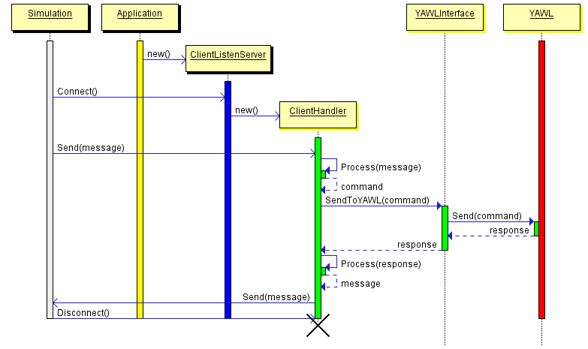

A 1. Sequence Diagram describing the communication process between the Simulation and YAWL as handled by the Veis Java Socket Server.